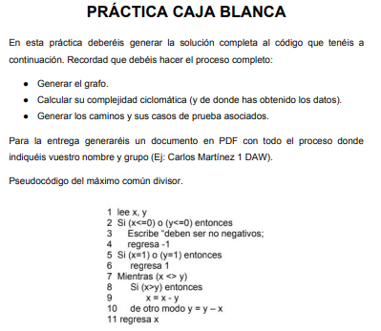

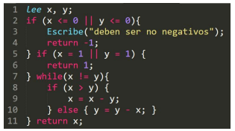

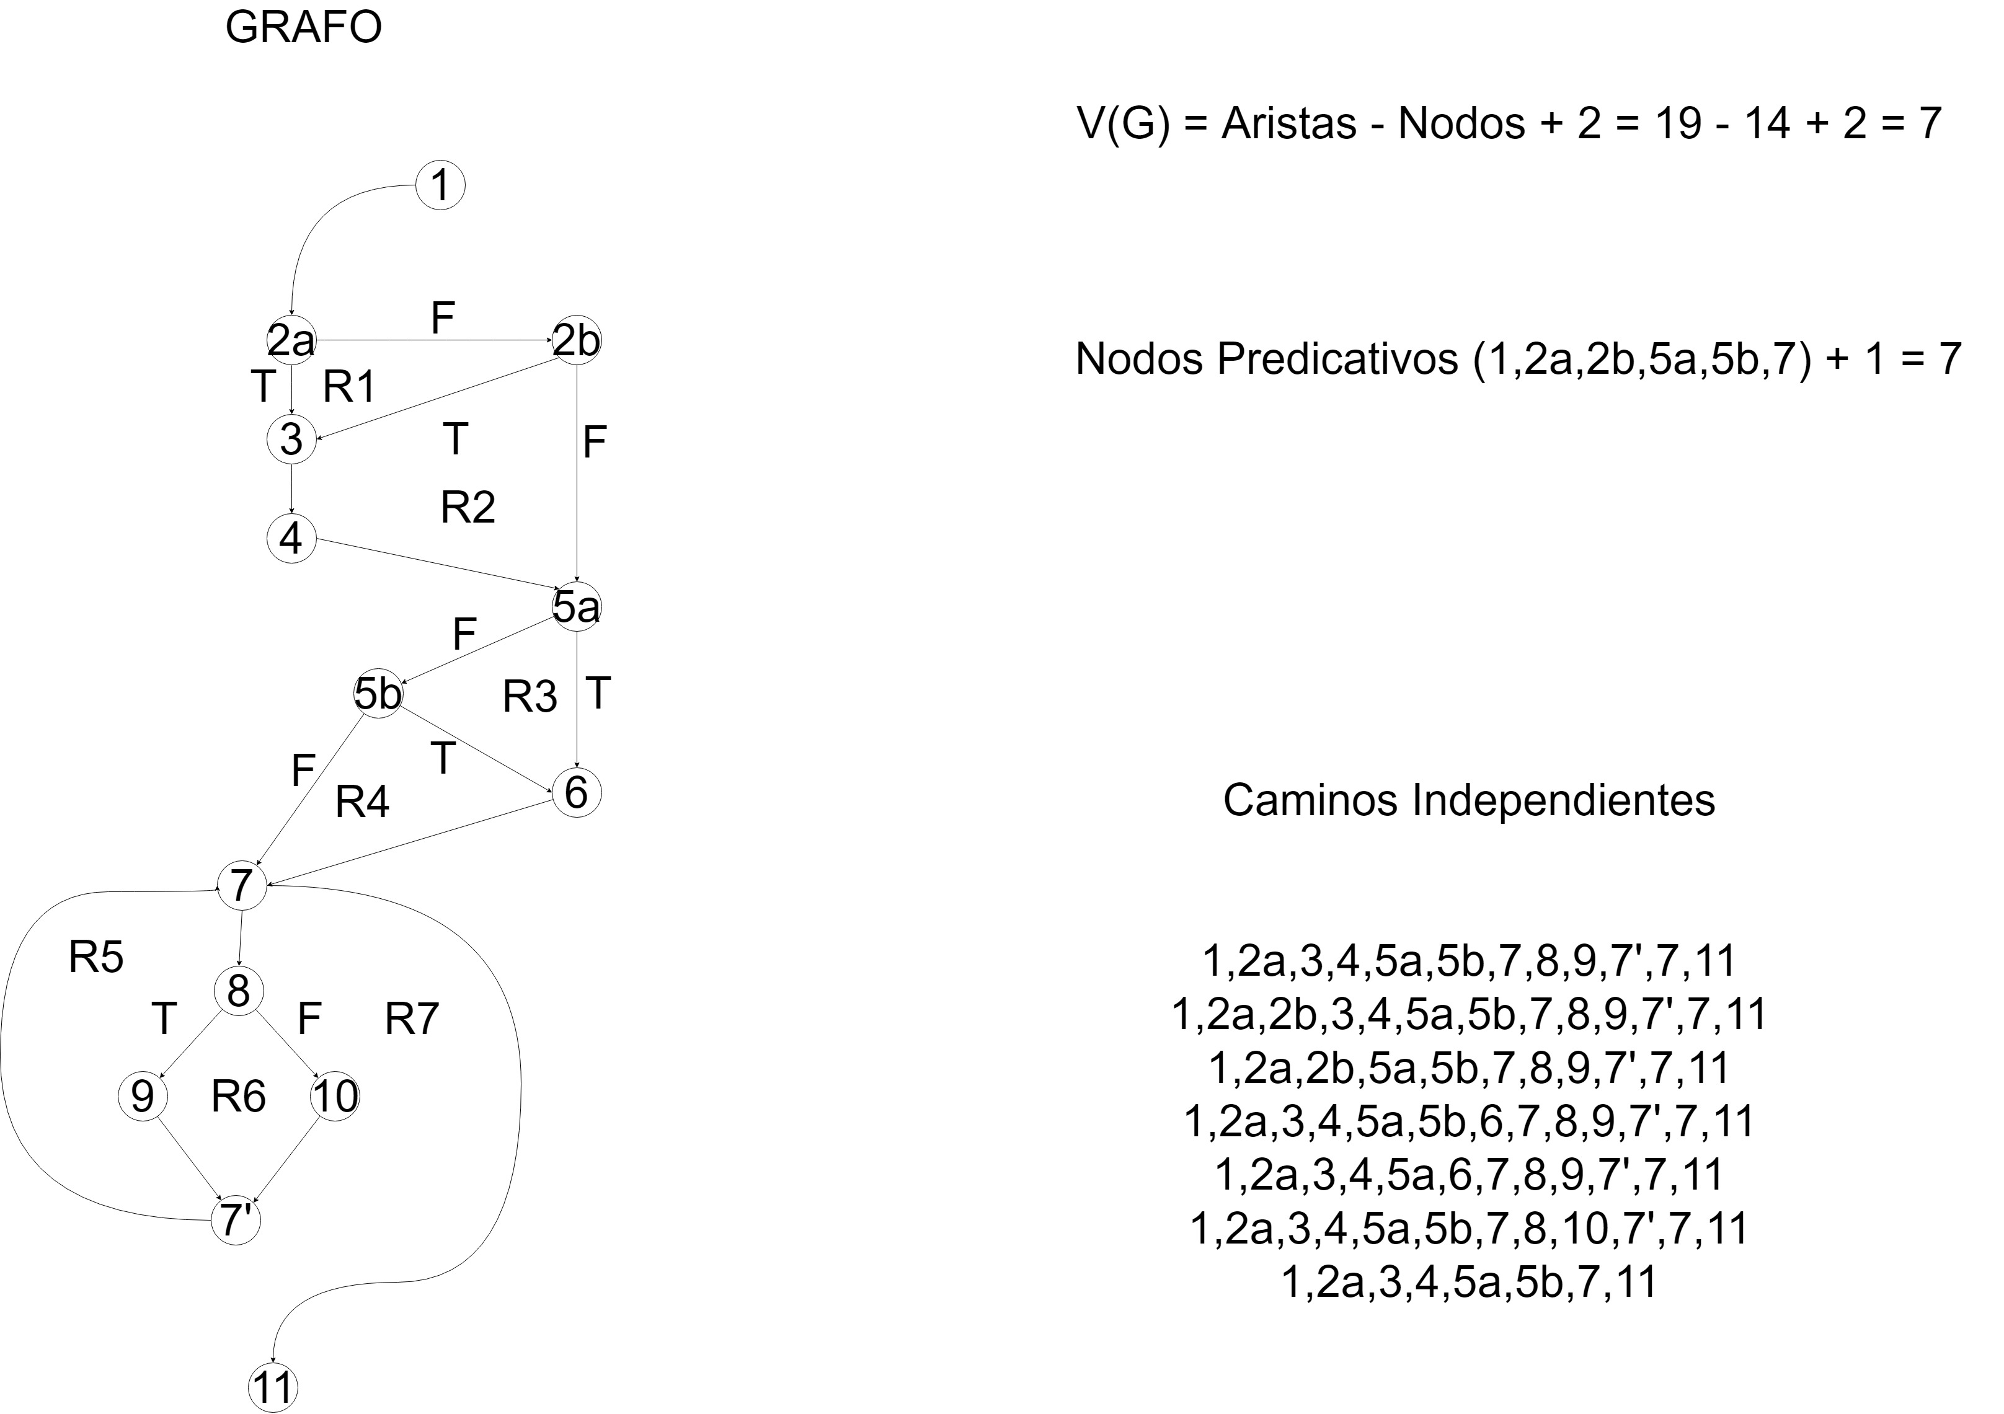

Camino | Entrada | Prueba | Salida
1,2a,3,4,5a,5b,7,8,9,7',7,11 | X<= 0 = true;  x = 1 = false;  y = 1 = false;  x>y = true; | X = -3;  y = 2; | X = 1;
1,2a,2b,3,4,5a,5b,7,8,9,7',7,11 | X <= 0 = false;  y <= 0 = true;  x = 1 false;  y = 1 = false;  x>y = true; | X = 3;  y = -2; | X = 1;
1,2a,2b,5a,5b,7,8,9,7',7,11 | X <= 0 = false;  y <= 0 = false;  x = 1 false;  y = 1 = false;  x>y = true; | X = 3;  y = 2; | X = 1;
1,2a,3,4,5a,5b,6,7,8,9,7',7,11 | X<= 0 = true;  x = 1 = false;  y = 1 = true;  x>y = true; | X= -2;  y = 1; | X = 1;
1,2a,3,4,5a,6,7,8,9,7',7,11 | X<= 0 = true;  x = 1 = true;  x>y = true; | X = -1;  y = 0.5; | X = 0.5;
1,2a,3,4,5a,5b,7,8,10,7',7,11 | X<= 0 = true;  x = 1 = false;  y = 1 = false;  x>y = false; | X = -3;  y = 4; | X = 2;
1,2a,3,4,5a,5b,7,11 | X<= 0 = true;  x = 1 = false;  y = 1 = false; | X = -3;  y = 2; | X = 1;

